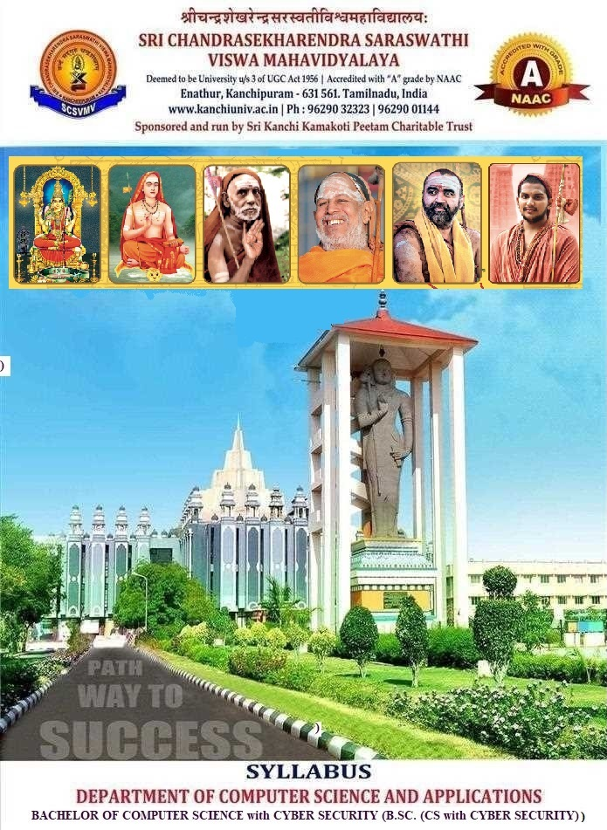

CURRICULUM & CREDITS

Se m | Course Code | Category | Paper | Hrs | L | T | P | Total Credits
SEMESTER - I
I |  | Multidisciplinary | Tamil - I / Hindi - I / Sanskrit - I | 3 | 2 | 1 | 0 | 3
I |  | AEC-1 | Communicative English | 3 | 2 | 1 | 0 | 3
I |  | Major-1 | Digital Principles & Its Applications | 4 | 3 | 1 | 0 | 4
I |  | Major-2 | Problem solving Techniques in C | 4 | 3 | 1 | 0 | 4
I |  | Minor-1 | Allied Mathematics - I | 4 | 3 | 1 | 0 | 4
I |  | SEC-1 | Problem solving Techniques in C Lab | 4 | 0 | 0 | 4 | 2
I |  | VAC-1 | Indian Culture | 1 | 1 | 0 | 0 | 1
I |  | VAC-2 | Principles of Environmental Science | 2 | 2 | 0 | 0 | 2
Total |  |  |  | 25 | 16 | 5 | 4 | 23
SEMESTER -II
II |  | Multidisciplinary | Tamil - II / Hindi - II / Sanskrit - II | 3 | 2 | 1 | 0 | 3
II |  | AEC-2 | Functional English | 3 | 2 | 1 | 0 | 3
II |  | Major-3 | Data Structures and Algorithms | 4 | 3 | 1 | 0 | 4
II |  | Major-4 | Cyber Crime & Mitigation Techniques | 4 | 3 | 1 | 0 | 4
II |  | Minor-2 | Allied Mathematics - II | 4 | 3 | 1 | 0 | 4
II |  | SEC-2 | Data Structures and Algorithms Lab | 4 | 0 | 0 | 4 | 2
II |  | VAC-3 | Yoga | 1 | 1 | 0 | 0 | 1
II |  | VAC-4 | Fundamentals of Human Rights | 2 | 2 | 0 | 0 | 2
Total |  |  |  | 25 | 16 | 5 | 4 | 23

 | PROBLEM SOLVING TECHNIQUES IN C | L | T | P | C
 | PROBLEM SOLVING TECHNIQUES IN C | 3 | 1 | 0 | 4
(For Students admitted from 2026 onwards)
Common for B.Sc. (CS with Cyber Security)/BCA

COURSE OBJECTIVES
- To help the students to learn programming concepts using C Language
- To learn the fundamentals of PST and methodologies which are essential for building good C programs
- To demonstrate a thorough understanding of modular programming by designing programs which require the use of programmer-defined functions
- To impart the knowledge about pointers which is the backbone of effective memory handling
- To demonstrate adeptness of file access in developing solutions to problems

COURSE OUTCOMES
- Learn the fundamental programming concepts and methodologies, which are essential for building good C programs.
- Understand the modular programming by designing programs, which require the use of programmer defined functions.
- Acquire the knowledge about pointers
- Learn about the Storage Classes and building good C programs.
- Obtain the knowledge of writing programs for file access.

SYLLABUS
Unit I: Problems and Problem Instances
Types of Computational Problems- Classification of Problem- Analysis of Problems- Solution Approaches- Algorithm Development- Analysis of Algorithm - Role of Data Structures in ProblemSolving- Problem Solving Steps-Modular Programming. 12

UNIT –II: C fundamentals:
Character set - Identifier and keywords - data types - constants- Variables - Declarations -Statements - Operators – Expressions – Built in functions – Input and Output Operations. 12

UNIT – III: Control Structure Statements and Arrays
Flow of control - if, if else, While, do-while, for loop, Nested control structures - Switch, breakand continue, go to statement – Arrays. 12

UNIT – IV: Functions & Structure:
Definition - Prototypes – Passing arguments – Recursion- Storage Classes – Structure-Union. 12

UNIT – V: Pointers and File:
Declarations - Structures and Pointers - Passing pointers to Functions - Pointer and Arrays –Arrays of Pointers - Files: Creating, Processing, Opening and Closing a data file- Debugging. 12
TOTAL: 60
TEXT BOOKS
1. Harvey Deitel and Paul Deitel, “C How to Program”, Pearson India, 9th Edition, 2015. – Unit II to IV
2. R G Dromey, “How to Solve It by Computer”, Pearson India, 2007. – Unit I

REFERENCE BOOKS
1. Brian W. Kernighan and Dennis Ritchie, “The C Programming Language”, Pearson, 2nd
Edition, 2015.

WEB REFERENCES:
- https://www.geeksforgeeks.org/c/c-programming-language/
- https://www.learn-c.org/
- https://en.cppreference.com/w/c

Prepared by | Existing BCA Syllabus
Verified by

 | DIGITAL PRINCIPLES & ITS APPLICATIONS | L | T | P | C
 | DIGITAL PRINCIPLES & ITS APPLICATIONS | 3 | 1 | 0 | 4
(For Students admitted from 2026 onwards)
Common for B.Sc. (CS) / BSc (CS with Cybersecurity)

COURSE OBJECTIVES
- To learn about the basic concepts of Digital Computer Fundamentals
- To get through knowledge about the concepts of logic gates, Boolean Algebra
- To Learn the combinational circuits and sequential logic
- To study about the various counters and memory
- To know the concepts of registers.

COURSE OUTCOMES
- Know the basics of Digital Computer Fundamentals
- Understand the theory of logic gates, Boolean Algebra
- Acquire knowledge of the combinational circuits and sequential logic
- Know about various counters and memory
- Obtain and Understand the concepts of registers

SYLLABUS

UNIT – I INTRODUCTION TO NUMBER SYSTEM
Number Systems and Codes: Number System, Base Conversion, Binary Codes. Code Conversion - Digital Logic: Logic Gates, Truth Tables, Universal Gates. 12
UNIT – II BOOLEAN ALGEBRA:
Truth Table - theorems and properties of Boolean algebra, Boolean functions, canonical and standard forms, K-map (upto 4 Variables), Don’t care conditions. 12
UNIT – III COMBINATIONAL CIRCUITS:
Digital logic gates - Design procedure - Universal Gates – Adder – Subtractor - Encoder – Decoder – Multiplexer – Demultiplexer. 12
UNIT – IV SEQUENTIAL CIRCUITS:
Flip flop – SR Flip flop – D Flip flop T Flip Flop- JK Flip flop - Master Slave Flip Flop. 12
UNIT – V REGISTERS AND COUNTERS
Introduction to Registers, Shift Left Register, Shift Right Register, Introduction to Counters, Up Counter, Down Counter 12
TOTAL : 60

TEXTBOOKS:
- M. Morris Mano, Digital Logic and Computer Design, Prentice Hall of India, Eastern Economy edition 2010.

REFERENCE BOOKS:
- Floyd, ‘Digital Fundamentals’, 11th edition, Pearson Education, 2015. – Highly Visual

WEB REFERENCES:
- https://www.geeksforgeeks.org/digital-electronics-logic-design-tutorials/ - UNIT I & II
- https://www.tutorialspoint.com/digital_circuits/index.htm
- https://www.allaboutcircuits.com/textbook/digital/ - UNIT IV & V
- https://nptel.ac.in/courses/108105132
- https://nptel.ac.in/courses/106105185
- https://circuitverse.org/ - Free browser based simulator

Prepared by | Dr.J.Srinivasan
Verified by | 1.Mr.Krishnamoorthy.M  2. Dr. N. R. Ananthanarayan

 | PROBLEM SOLVING TECHNIQUES IN C LAB | L | T | P | C
 | PROBLEM SOLVING TECHNIQUES IN C LAB | 0 | 0 | 4 | 2

(For Students admitted from 2026 onwards)
Common for BCA/ B.Sc. (CS with Cyber Security)

COURSE OBJECTIVES
- To be able to get trained in programming skills using C
- To help the students to write the programs using conditional Statements and Lopping Statements.
- To learn and write the programs for Array and structure.
- To learn about the usage of functions.
- To impart the knowledge about pointers, files and effective memory handling

COURSE OUTCOMES
- Ability to implement application programs using C Language
- Able to implement structure and functions concepts
- Understand various string functions
- Knowledge on implementing the concepts of Pointers
- Create and use of the file operations.
LIST OF EXERCISES
1. Write a Program to generate a Fibonacci Series
2. Given a positive integer value n (>= 0) display number, square and cube of numbers from
1 to n in a tabular format?
3. Given an input positive integer number, display odd numbers from in the range [1,n]?
4. Compute character grade from the marks (0 ≤ marks ≤ 100) of a subject. Grading Scheme:
80-100: A, 60 - 79: B, 50 - 59: C, 40-49: D, 0-39: F? Solve this using switch case
5. Display following patterns of n rows (n > 0), For the below examples n = 5?
$
$$
$$$
$$$$
$$$$$
6. Check if a given positive integer number is a palindrome or not?
7. Implement your own string length and string reversal functions?
8. Write a Program to sort an array.
9. Write a Program to find the factorial of an integer using recursion.
10. Write a Program to swap two values using function pointer.
11. Write a Program to store student’s information using Structure.
12. Write a Program to perform read and write operation on a file.

Prepared by | Dr. S. Babu
Verified by | 1. Dr.S.Prakasam  2. Mr.R.Saravanan

 | CYBER CRIMES & MITIGATION TECHNIQUES | L | T | P | C
 | CYBER CRIMES & MITIGATION TECHNIQUES | 3 | 1 | 0 | 4
(For Students admitted from 2026 onwards)

COURSE OBJECTIVES:
- To overview of crimes involving the use of computer technology and the internet
- To know how computer related crimes are committed and how they are investigated.
- To understand computer crime scene management and thelegal issues involved in the prosecution of computer crimes.

COURSE OUTCOMES:
On completion of the course, student will be able to:
- Identify different types of cyber crime
- Describe cybercrime and criminal groups that engage in cyber crime
- Identify and discuss the structures and characteristics of criminal groups that engage in cyber crime
- Explain and analyse the ways in which information and communication technology is used to commit cyber crime
- critically evaluate the measures used to counter cyber crime
SYLLABUS

UNIT -I Introduction to Cyber Security:
Basic Cyber Security Concepts, layers of security, Vulnerability, threat, Harmful acts, Internet Governance – Challenges and Constraints, Computer Criminals, Cyber Threats-Cyber Warfare, Cyber Crime, Cyber terrorism, Cyber Espionage, etc., Comprehensive Cyber Security Policy. 12

UNIT – II Fundamentals of Cyber Crime:
Cybercrime: Introduction, Motivation and Methods - The Scale of the Problem and Reasons for the Growth of Cybercrime - Profiling Cybercriminals - Challenges for Criminal Justice and Law Enforcement - The Future of Cybercrime.Emerging Threats: Expected Targets and Forms - Criminal Statues - 2.3 Other Offences Associated with Hacking. 12

UNIT – III Injection of Malicious Code in Application:
Introduction - Types of Malicious Code - Threats Posed by Viruses, Worms, and Trojan Horses - Legislative Approaches. 12

UNIT – IV Attempts and Impact of Phishing in Cyberworld:
The Problem of Phishing - Impact and Harm Generated by Phishing - Mechanisms of Cyberspace Phishing - Dragnet Method - Rod—and—Reel Method - Lobsterpot Method - Gillnet Phishing - Political Phishing. 12

UNIT – V Anonymity, Privacy and Security Issues in Cyberworld:
Introduction - Anonymity in Cyberspace Impact and Harm Generated by Anonymity - Regulating Anonymity in Cyberspace -The Case Law. 12

TEXT BOOK:
1. Studies in Computational Intelligence, Volume 593, Series editor Janusz Kacprzyk, Polish Academy of Sciences, Warsaw, Poland. Springer. – UNIT I & V (Cybercrime, Digital Forensics and Jurisdiction (SCI Vol. 593)
2. Computer Forensics: Investigating Network Intrusions and Cyber Crime – UNIT III
3. Cyber Criminology: Exploring Internet Crimes and Criminal Behavior 2011, by K. Jaishankar. –UNIT II & IV

REFERENCES:
1. The NICE Cyber Security Framework: Cyber Security Intelligence and Analytics 2019, by Izzat Alsmadi.
2. Cyber Security on Azure: An IT Professional’s Guide to Microsoft Azure Security Center, 2017 Apress, by Marshall Copeland (auth.)

WEB REFERENCES
- NIST Cybersecurity Framework – UNIT I
- https://www.w3schools.com/cybersecurity/cybersecurity_syllabus.php - UNIT I
- https://www.youtube.com/watch?v=LIOeHVzeLUA – UNIT III
- https://jaipur.manipal.edu/fosta/img-fos/programs/Cyber-security/Syllabus_MSc-2026-27.pdf - UNIT III
- https://www.ques10.com/p/49373/methods-of-phishing-1/ - UNIT IV
- https://www.crime-research.org/articles/phishing-in-cyberspace-issues-and-solutions - UNIT IV
- https://www.sciencedirect.com/science/article/abs/pii/S1361372305001454 - UNIT V

Prepared by | Mr. J. Seetha Raman
Verified by | 1. Mr.R.Saravanan  2. Dr. K.Srinivasan

 | DATA STRUCTURES AND ALGORITHMS | L | T | P | C
 | DATA STRUCTURES AND ALGORITHMS | 3 | 1 | 0 | 4
(For Students admitted from 2026 onwards)
Common for B.Sc. (CS) / B.Sc. (CS with Data Science) / B.Sc. (CS with Cyber Security)

OBJECTIVES
- To gain knowledge in designing algorithms to solve problems.
- To understand the concept of linear and nonlinear data structures.
- To know the concept of various sorting and searching techniques.
- To apprehend the tree traversal and searching
- To acquire knowledge in graph traversal and searching.

OUTCOMES
- Compute and Analyze algorithms for efficiency using asymptotic notations.
- Develop knowledge about basic data structures like arrays, linked list, trees.
- Solve problems by applying suitable data structure.
- Define graph and illustrate graph traversal.
- Design and develop projects requiring implementation of the data structure.

SYLLABUS
UNIT – I
Definition of a Data structure - primitive and composite Data Types- Asymptotic notations. Arrays - Operations on Arrays. 12
UNIT – II
Sorting - Bubble sort - Insertion sort - Selection sort - Quick sort - Merge sort - Searching - Linear search - Binary search.. 12
UNIT – III
Stacks – Operations on Stack-Applications of Stack - Infix to Postfix Conversion -recursion - Queues - Operations on Queues, Circular Queue. 12
UNIT – IV
Introduction to single and double Linked lists - Representation – operations on single linked list - Linked stacks and queues. 12
UNIT – V
Trees - Binary Trees - Memory representation - Traversal algorithms - Binary search trees - Graph - Definition, Types of Graphs, Graph Traversal – BFS and DFS. 12
TOTAL: 60

TEXT BOOKS:
- Seymour Lipsuschutz Theory and Problems of Data Structures, Tata Mc.Graw Hill First Edition, Reprint 2013 – UNIT I to IV
- Jean-Paul Tremblay, Paul G. Sorenson, ’An Introduction to Data Structures with Application’, TMH, 2017. – UNIT V

REFERENCE BOOKS:
- E. Horowitz and S. Shani Fundamentals of Data Structures in C++, Galgotia
Pub. 1999, E- book 2012. – UNIT II to IV
- R. Kruse C.L. Tondo and B. Leung, Data Structures and Program design in C, PHI, 2nd Edition, 1997. – UNIT I, III, IV

WEB RESOURCES:
- https://www.geeksforgeeks.org/data-structures/ - UNITS I to IV
- https://visualgo.net/en simulator for UNIT IV, V

Prepared by | (Existing BCA Syllabus)
Verified by

 | DATA STRUCTURES & ALGORITHMS LAB | L | T | P | C
 | DATA STRUCTURES & ALGORITHMS LAB | 0 | 0 | 4 | 2
(For Students admitted from 2026 onwards)

COURSE OBJECTIVES
- To be able to get trained in programming skills using C++.
- To help the students to write the programs for Array operations.
- To learn and write the programs for Stack and Queue operations.
- To learn and write the programs for Sorting Techniques.
- To impart the knowledge to write the program for Binary Search

COURSE OUTCOMES
- Ability to implement application programs using C++ Language
- Able to implement Array operations.
- Understand and implement Stack and Queue operations.
- Knowledge on implementing the Sorting Techniques.
- Knowledge on implementing Binary Search

LIST OF EXERCISES

- Program for Implementation of Stack using Array
- Program for Implementation of Queue using Array
- Program to Implement Circular Queue.
- Program to Implement Linked list.
- Program to Implement Doubly Linked list.
- Program To Arrange the list of numbers in ascending order using Bubble Sort
- Program to arrange the list of numbers in ascending order using Insertion Sort.
- Program to Implement Quick sort.
- Program to Implement Linear search.
- Program to implement Binary Search

Prepared by | Dr. J. Srinivasan
Verified by | 1.Mr.Krishnamoorthy.M  2. Dr. N. R. Ananthanarayan

